Walk 37 Hill and Lake Around Boddingham
Last walked in October 2016

Description. 5 km (3.1 miles). A moderate walk with some steep slopes thru wooded area, along a lake and across country.
Start. Bodenham. Grid reference Explorer Map 202 Grid 530509.
Directions from Whitecross roundabout (Turn milometer to zero). Take the A4110 to Canon Pyne (Three Elms road) and after 1 mile, at traffic lights, you TR onto the A4103 to Worcester (Roman road). At the second roundabout, 3.2 miles, you TL to Bodenham. Go thru Bodenham and at 9.4 miles, just before ‘England’s Gate Inn’, you TL to Bodenham Church, (if you reach the main T Junction road you have gone to far). At 10.3 miles you TL by a memorial cross and head towards the church. You can park-up on the R hand side, near to the end of the road and opposite a school, total of 10.4 miles.

1. Bodenham church. Continue on to the end of the ‘no thru road’, which bends R then L to reach the church lych-gate. The parish church of St Michael and All Angels at Bodenham is set in a beautiful location beside the peaceful River Lugg. The church is primarily 14th century, in the Decorated Gothic style. In the 12th Century, Bodenham’s Church was dedicated to St Mary (Our Lady) rather than to St Michael as it is today. Enter the churchyard thru a lych-gate. TL and walk along the edge of the churchyard to go thru a kissing gate in the corner into a field{F1}. Continue in the same direction, keeping to the fence on your L; pass a school sports field to reach the fence corner. Carry on in the same direction and cross the field, going thru the gap in the hedge ahead, into {F2}. Continue across the field and go thru a wooden kissing gate in the far R hand corner. Follow the path for a short distance and go thru another wooden kissing gate. Carry on along the R edge of the field, keeping to the chopped down tree line, and go thru another wooden kissing gate onto the main road.

2. (Pigeon House). TL along road for a short distance then TR onto a bridleway by Bank House. As you approach the next house, Bunhill, you TL, to wander up an enclosed green lane that’s a Public Bridleway. At the end of the enclosed green lane you pass thru a metal gate into {F3}. Bear R and go uphill, keeping the wide grassy ditch and a few trees on your R side, to reach the field end. Go thru a metal gate and continue on along the wide grassy ditch to go thru another metal gate into {F4}. Continue in the same direction, with the woods on your L, and go thru a metal gate into {F5}. At the end of {F5}, by the corner of the woods, go thru a metal gate and onto a stony tree lined farm track, (or walk over the cattle grid which is off to your R).

3. (Henhouse). Just before the farm buildings, by a circular plantation of trees on you’re L, TL and cross over the field. TL and walk alongside the fence on your R, and after about 130m you TR across a stile into the woods. Follow a woodland path downhill, after about 70m you go down six wooden steps to reach a prominent track where you TL, walk about 15m then TR and continue down a smaller track. Continue down the track, pass a stile and more wooden steps to finally emerge onto the road by Bodenham Manor entrance. TL, continue along the road and TR thru the first metal gate into an orchard. Bear R as you walk downhill to the Lady Close Orchard commemorative stone in the middle.

4. Boddingham Lake. Continue diagonally across the field to reach the end, and go thru the smaller of two wooden gates. A wooden signpost on your L shows you the direction for the ‘Bird Hide’. Continue ahead with the lake on your L to visit the Bird Hide. Bodenham Lake Nature Reserve is 110 acres of varied habitat including riverside meadows, veteran orchard, newly planted orchard, a 'gravel' area and wet woodland and the lake itself is the largest area of open water in the county. It is a very relaxing, tranquil place to visit with breath-taking views across the great expanse of water, a perfect place to come on a lazy afternoon to have a picnic! It is a very important winter-feeding area for wildfowl with approximately half of the site managed as a nature reserve, with no public access, but you can stroll thru the beautiful orchards and meadows and on to the bird hide where you can sit and watch the birds on the lake. When you are ready, retrace your steps back to the signpost.
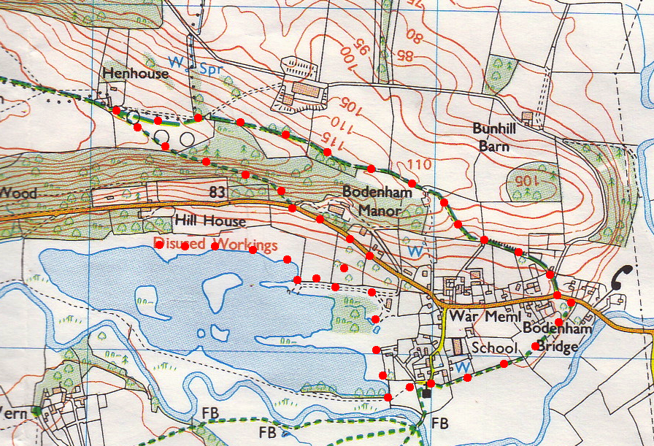

5. Bodenham Sailing Centre. TR and go thru the smaller of two wooden gates, then after a short distance you reach ‘Bodenham Sailing Centre’ compound. TL, continue along a wide stony track to reach a picnic table and signboard on your L, (there are metal gates in front, which you don’t go thru). Bear R and continue along the wide stony track to pass thru the smaller of two metal gates, and head on towards a tall hedgerow of conifer trees. Continue along the track, pass a black and white house on your L, then draw level with the church, now one field away, to go thru the smaller of two metal gates, continue on for a few paces to reach the sign and info board on the bank of the River Lugg. TL, go thru a small wooden gate and follow the path to the church.
4/5
3
2
1

